Name ___________________________________ Date _______________________________________

Sustainability Activity 3

Sustainability Case Studies

**FOLLOW DIRECTIONS!!!**

1. Get a book.
2. Turn to Sustainability Unit, Activity 3, Pages 14 – 21.
3. This reading is about two communities: Bed ZED and Darewadi Village. You are to find out information about Darewadi Village.
4. Look at the chart below about Bed ZED. It has been done for you.



1. Read page 19 – 20 about Darewadi Village.
2. Your job is to complete the chart on the next page about Darewadi Village!

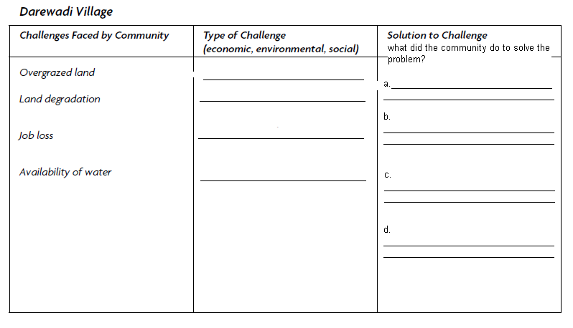

1. Answer the questions:
2. For Darewadi village, do you think more of their problems were environmental, economic or social?  
   _______________________________________________
3. Why did you answer a. the way you did?  
   _______________________________________________________________________________________
4. How did Darewadi village use science or technology to change their community?  
   _________________________________________________________________________________________________________________________________________________________________________________________________________________________________________________________________________________

SUSTAINABILITY

Activity 3

Packet

Name _________________

Date _________________

Period ________________

You must get each of the following checked before going on:

Darewadi reading _____

Darewadi chart ____

Question a. ____

Question b. ____

Question c. ____

Puzzle ____